Infrared Sensors
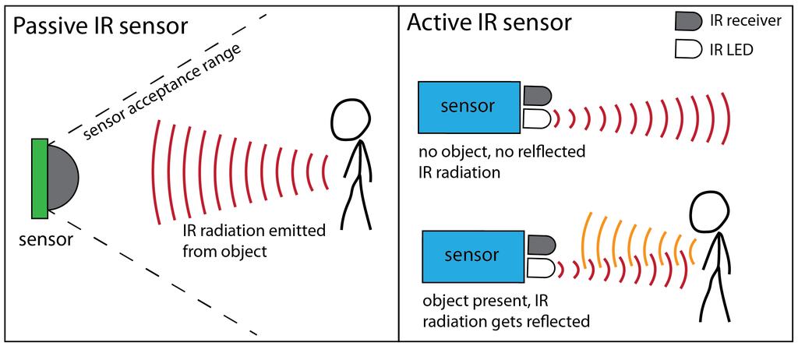

Active IR sensors emit IR waves that bounce off an object and are received by an IR receiver. This is used to detect an object is present, like echolocation.
An IR sensor with an ADC will produce a value for the microcontroller between 0 and 2^(ADC resolution). For example, a 10-bit ADC will have 1024 steps (0 - 1023).
This can be used for detecting colours, since some colours absorb the waves better than others.
- Black absorbs much of the IR radiation, meaning that the sensor will receive a low ADC value.
- White reflects most of the IR radiation, meaning that the sensor will receive a high ADC value.
This knowledge can be used to keep a line-following robot on path – since if white is detected (high sensor input) the car can adjust until it is not present.

Ultrasonic Sensors

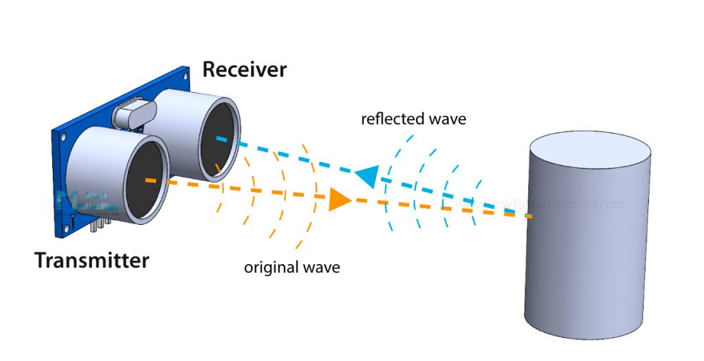

Work like IR – emits wave and detects object if wave bounces back.
Used to detect objects in the way. Higher value the closer object is. This can be used to trigger beeping faster and louder based on proximity and trigger an interrupt to stop the car if too close.

